Scholarship Reviewer Chairs

Signing in to the AcademicWorks Scholarship System
Selected faculty and staff will receive an e-mail invitation prior to the new year’s awarding cycle to begin reviewing scholarship applicants.

New Users
After clicking the invitation token, new users will be taken to an account setup screen where they will be required to set up a password.
Returning Users
Returning users will be directed to sign in to AcademicWorks using their previously set password.
All Users
Whenever signing in to AcademicWorks at https://apsu.academicworks.com/users/sign_in, be sure that the “References and Reviewers” tab is selected. Otherwise, you may sign in as an applicant.

Familiarizing Yourself with the System
The Reviewer Chair will see a list of scholarships to which they have been assigned reviews.
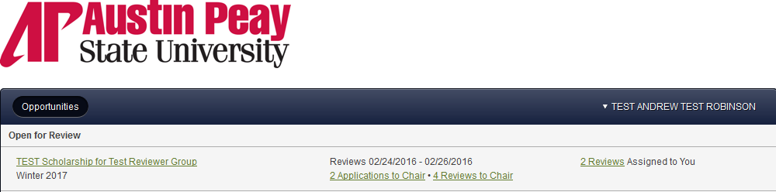

DETAILS |  | APPLICATIONS TO CHAIR | REVIEWERS TO CHAIR | REVIEWS ASSIGNED TO YOU
Details of the scholarship are so important. Viewing the description and available award amount is essential in the scholarship selection process. We want to ensure we are selecting recipients that meet the donors’ criteria. We also want to offer award amounts that correspond to the year’s spending figure.
- Basic Information
- Fund Information --- Spending for the year will be noted as “Remaining Funds”
- Opportunity-Specific Information ---- Important to note qualification criteria and if prior recipients should be considered for renewal.
- Dates
- Questions

Applications to Chair will allow you the access to generate an Excel report of the scholarship data for the applicants with the individual applicant pool. As Chair it will be very helpful if you generate the report and forward to the other members of the committee.

For instructions on how to generate your reports, see section titled Generating an Excel Report located below this chart.

 | Reviewers to Chair will allow you to see ratings made by the other members assigned to your Reviewer Group. This could be a lengthy listing, as an applicant will be listed one time for each reviewer in your group.
Reviews assigned to you will be listed and you will have the ability to review individual applicant’s data and rate the students. For consistency we are suggesting a scale of 1-10 (with 10 being reserved for students of the highest quality).

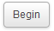
You take action by clicking on the “Begin” button.
- Review tab -- page that will provide you with a rating field and an area to describe any outstanding qualities of the student.
- Application tab – by clicking this tab you can review the student’s application to establish a rating.

Helpful feature: 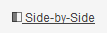

Clicking on “Side-by-Side” will allow you to split the screen between the Review tab and the Application tab. To Exit Side-by-Side view, click the link in the bottom left corner.

For more information about being a Reviewer, read the complete set of Reviewer’s Instructions at: https://www.apsu.edu/sites/apsu.edu/files/Scholarship_Reviewer_Instructions_Revised_2-26-16.docx

Generating an Excel Report:
While viewing Applications to Chair – scroll to the bottom of the frame and click on “Scholarship View”. It should be set as the default view, but if not use the dropdown box to select this option. If “Scholarship View” is not an option, please inform Sherri Devers.
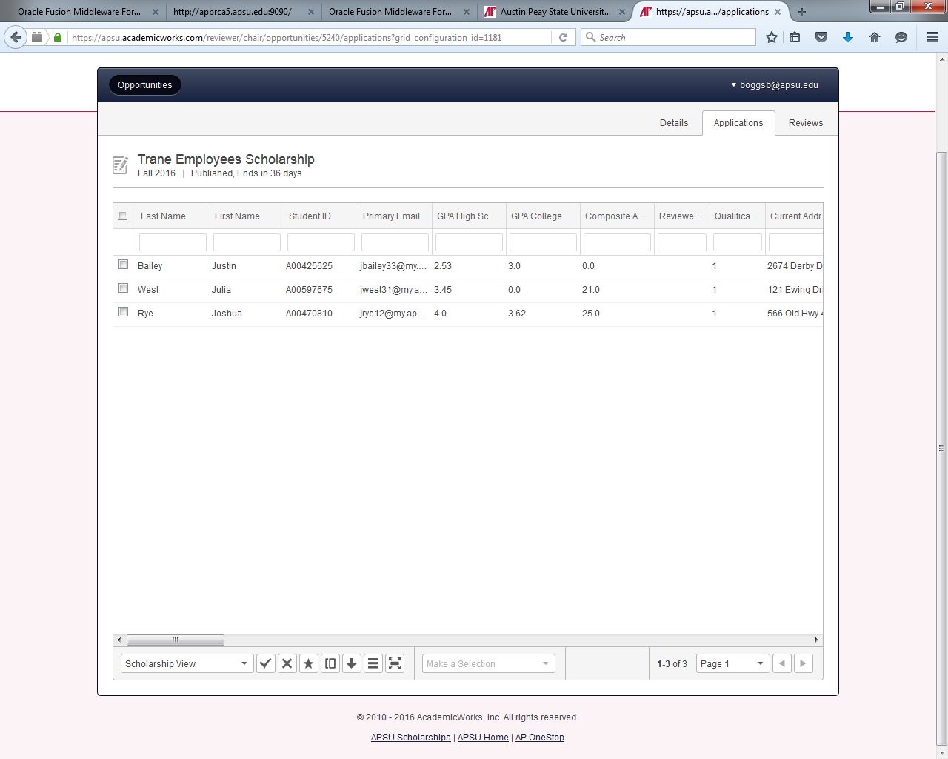

Then click the Download Report button. The report will be generated.
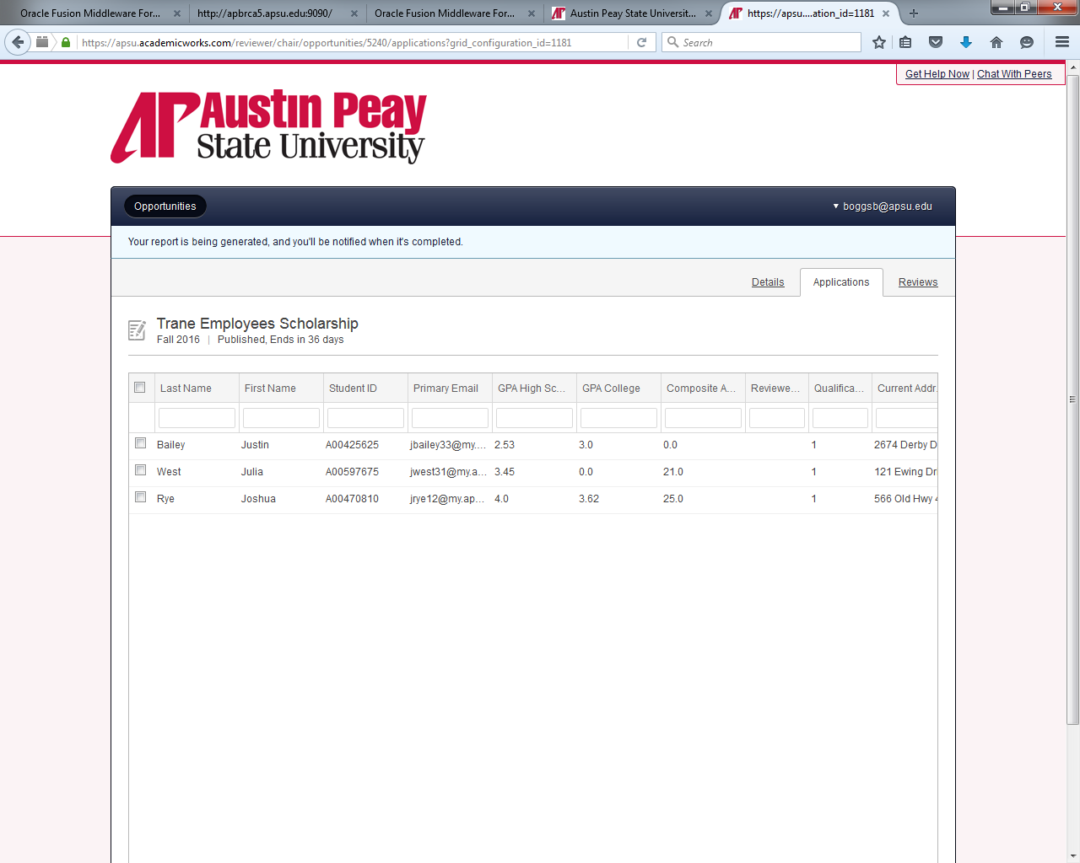
You will be notified when it is completed (via AP email – from Austin Peay State University Scholarships <APSUScholarships@apsu.edu>). The link in the email will direct you to log into the system to download your report.

Selecting Recipients and Notifying Financial Aid
Each department is free to design their own workflow for selecting recipients. However, we recommend the following procedure:

- Reviewers evaluate and rate all applicants.
- Reviewers share their top selections with the scholarship committee.
- The Reviewer Chair will have access to all Reviewers’ scores and comments.
- The scholarship committee determines the final selection(s).
- An authorized staff member fills out the scholarship recipient(s) using the Scholarship Award Submission Form located on the Staff Resources page at https://www.apsu.edu/scholarships/academic-scholarship-staff-resources
  - The Scholarship Award Submission Form is submitted to the Scholarship Coordinator in the Financial Aid Office. Early submissions benefit both the student and APSU by potentially increasing retention and recruitment.
  - Reminder:
    - Make evenly divided fall/spring disbursements
One semester awards must be approved by Advancement Office
    - Select alternate recipients
To ensure funds are spent and to avoid committees having to reconvene to make alternate selections
- We ask that departments do not send students notification of the scholarship, as official notification will come from the Office of Student Financial Aid

