Scholarship Reviewers

Signing in to the AcademicWorks Scholarship System
Reviewers are selected by the department chairs. Selected faculty and staff will receive an e-mail invitation prior to the new year’s awarding cycle to begin reviewing scholarship applicants.

New Users
After clicking the invitation token, new users will be taken to an account setup screen where they will be required to set up a password.
Returning Users
Returning users will be directed to sign in to AcademicWorks using their previously set password.
All Users
Whenever signing in to AcademicWorks at https://apsu.academicworks.com/users/sign_in, be sure that the “References and Reviewers” tab is selected. Otherwise, you may sign in as an applicant. You should sign in with your e-mail address.

Getting Started:

After logging in, the Reviewer will see the scholarship(s) in which they have been assigned the responsibility of selecting recipient(s).

Selecting either the name of the scholarship or the number of reviews assigned will take the Reviewer to the list of applicants.
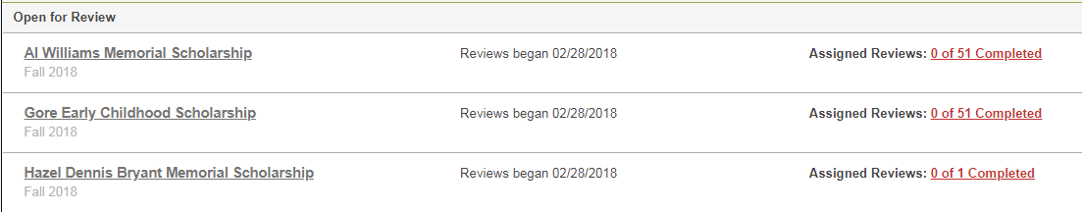

IMPORTANT TO NOTE: Before beginning to review your applicants, click on the “Opportunity Details” button to familiarize yourself with the scholarship criteria. We want to ensure the donor’s wishes are met through your selection process.

After clicking on “Opportunity Details” --- closely examine the following:
Description, which can reveal:
  - The donor’s criteria
  - Whether the scholarship is renewable
  - Whether the scholarship is shared with another department
Note: If scholarships are shared or on a rotating cycle, only the department assigned for that year will be able to view the applications.

Number of Awards, which will show how many awards may be offered.
Note: The number of awards will be up to the department’s discretion if the Award field indicates the amount may be divided by multiple recipients.

Award, which will provide a guideline for how much is to be spent for the academic year.

IMPORTANT TO NOTE: If the Number of Awards and Average Award reflect $0, funding information for the aid year has not yet been provided. When funding has been secured, you will be notified to make the scholarship selection.

The Review Process:

Click the “Begin” button in the action column to start evaluating the individual.
After clicking the Begin button – a rating page will display.
This page can be completed only AFTER you have evaluated the student’s application data.

Evaluating Student’s Application Data
To begin evaluating, the Reviewer will need to click on the individual’s “Application” tab.
This will allow the Reviewer to view the applicant’s General Application responses as well as any additional information gathered based on the specific scholarship requirements.

After clicking the Application tab, Reviewers will be provided 3 sections of data:
- General Application. This is the information the student supplied as they filled out the General Application, including data such as name, demographic information, grade level, activities, and achievements.
- Opportunity-Specific Questions. This is supplemental information that may be requested, such as essays, transcripts, or reference letters.
- Imported Information. This is the information pulled from Banner, including data such as Student ID, major, GPA, and ACT score.

Rating Your Candidate
To rate your candidate, click on the “Review” button.
This page will allow you to note your rating of the applicant. For consistency we are suggesting a scale of 1-10 (with 10 being reserved for the students of the highest quality). You will also have a field to describe any outstanding qualities of the student.

Under Describe This Applicant, the Reviewer may provide comments regarding the student’s application. Note that only the Reviewer who sets a comment and a Reviewer Chair will be able to view the comment.

At the bottom of the screen are two options: Save and Submit. Once a Reviewer has submitted, no additional updates can be made for this applicant.

Helpful Tip:
The “Side-by-Side” tab at the top right corner allows you to leave the rating page up as you actually review the candidate’s application data. This will split the screen. You can exit the feature at any time via the “Exit Side-by-Side” button.

Selecting Recipients and Notifying Financial Aid
Each department is free to design their own workflow for selecting recipients. We recommend the following procedure:
- Reviewers evaluate and rate all applicants.
- Reviewers share their top selections with the scholarship committee.
- The Reviewer Chair will have access to all Reviewers’ scores and comments.
- The scholarship committee determines the final selection(s).
- An authorized staff member fills out the selected scholarship recipient(s) using the Scholarship Award Submission Form located on the Staff Resources page at https://www.apsu.edu/scholarships/academic-scholarship-staff-resources
- The Scholarship Award Submission Form is submitted to the Scholarship Coordinator in the Financial Aid Office. Early submissions benefit both the student and APSU by potentially increasing retention and recruitment.
  - Reminder:
    - Make evenly divided fall/spring disbursements
One-semester awards must be approved by Advancement Office
    - Select alternate recipients to ensure funds are spent and to avoid committees having to reconvene to make alternate selections
- We ask that departments do not send students notification of the scholarship, as official notification will come from the Office of Student Financial Aid

